Creating Submodules in Git

Step 1 : Create a new Repository in git with name DevOps

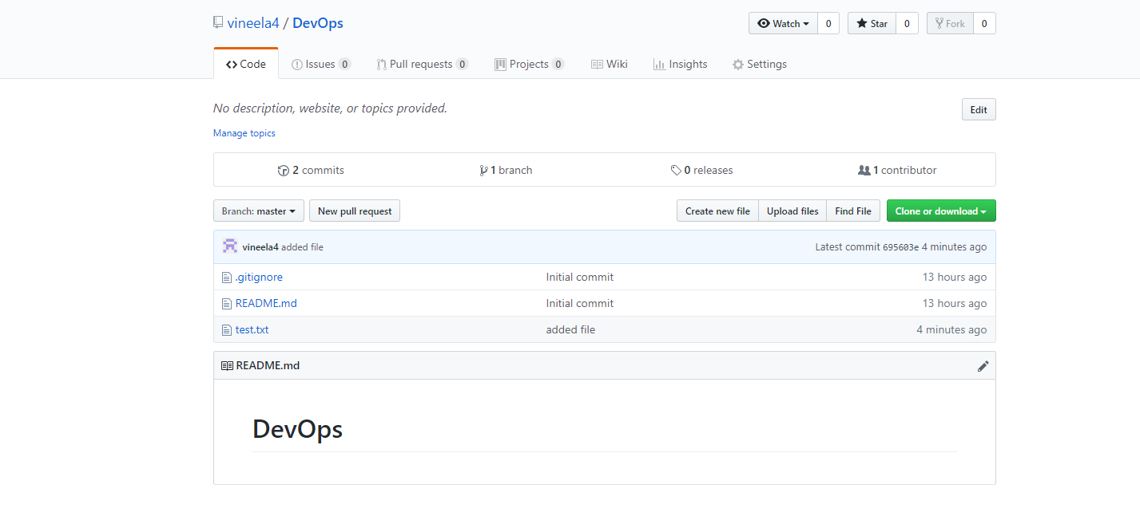

Step 2 : Create a another repository in git with name Developer1

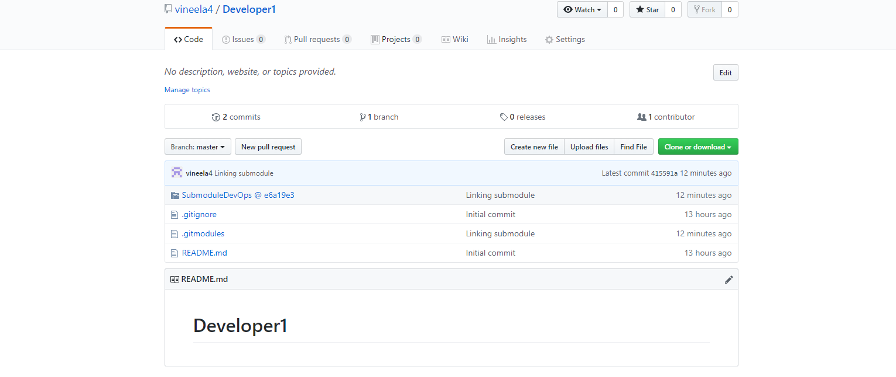

Step 3 : Creating Submodule in Developer1 Repository

Name - SubmoduleDevops

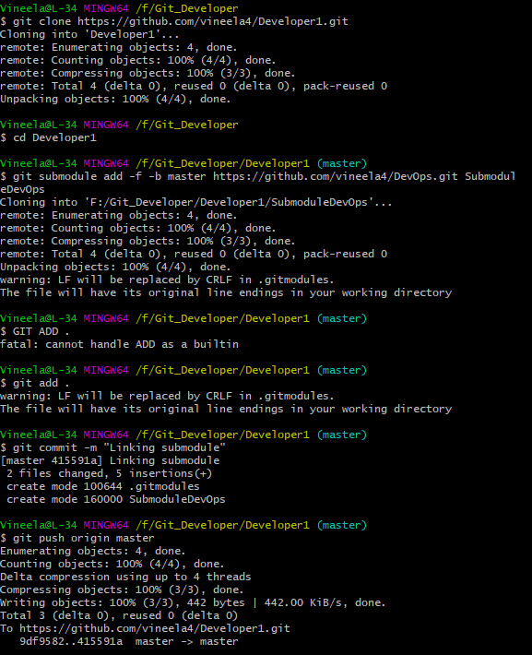

Step 4 : Add in DevOps Repository

.txt file is created in DevOps repository

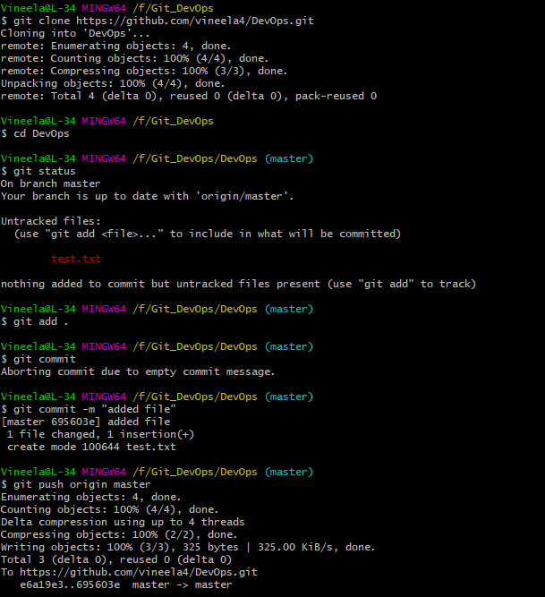

Step 5 : git submodule update --recursive --init

git submodule foreach git pull origin master

In Developer repository

